
Department of Computer Science and Engineering DevOps Lab - L3

Lab Assignment No: 7
Name of Student | Atharva Rale
PRN | 23070122174
Batch | 2023 - 2027
Class | CSE – B1
Academic Year & Semester | 2026 - 2027, 7th Semester
Title of Assignment | Pipeline with Parameters
Implementation & Theory | 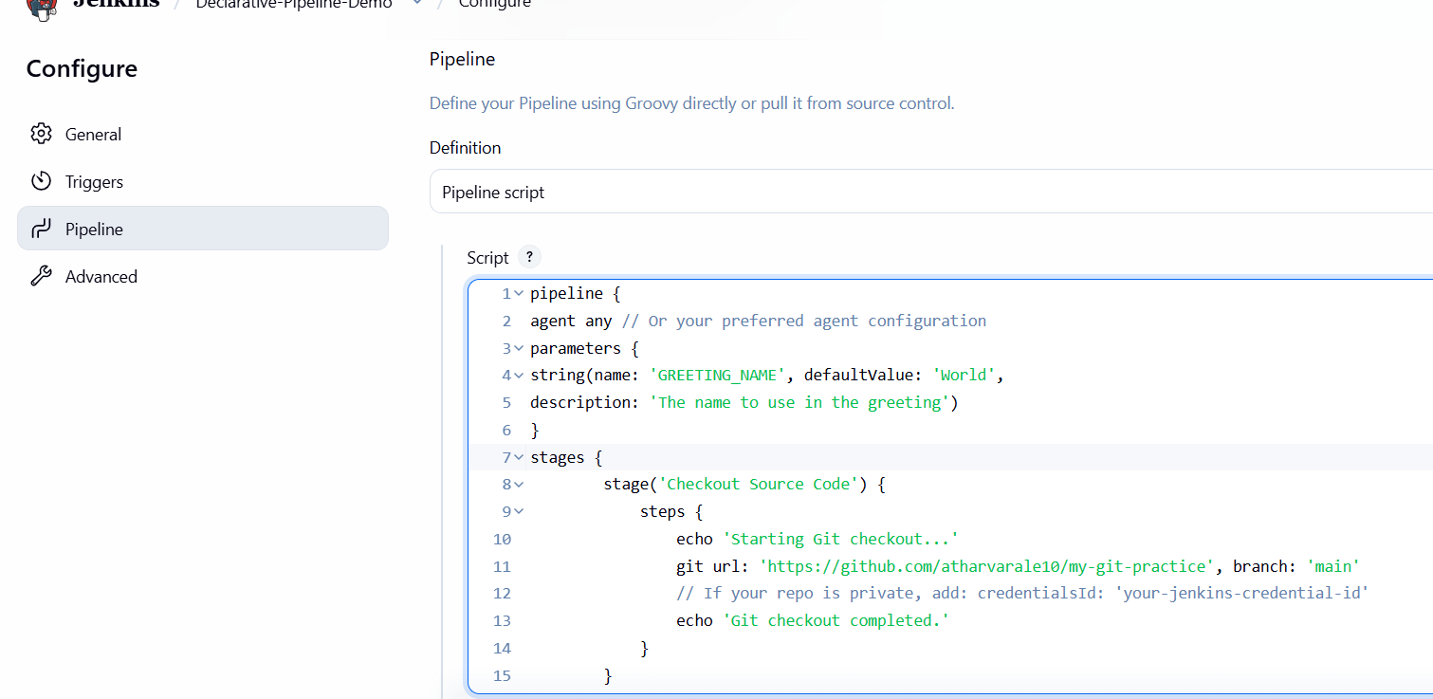  Open pipeline for editing — Navigated to Declarative-Pipeline-Demo  → Configure to add parameterization to the existing pipeline.

Add parameters block + Greeting stage — Updated the pipeline script to include a parameters block defining a string parameter GREETING_NAME (default World), and added a new Greeting stage that echoes Hello ${params.GREETING_NAME}.

Save configuration — Saved the updated script; the job sidebar changed from "Build Now" to "Build with Parameters," confirming Jenkins recognized the parameter.
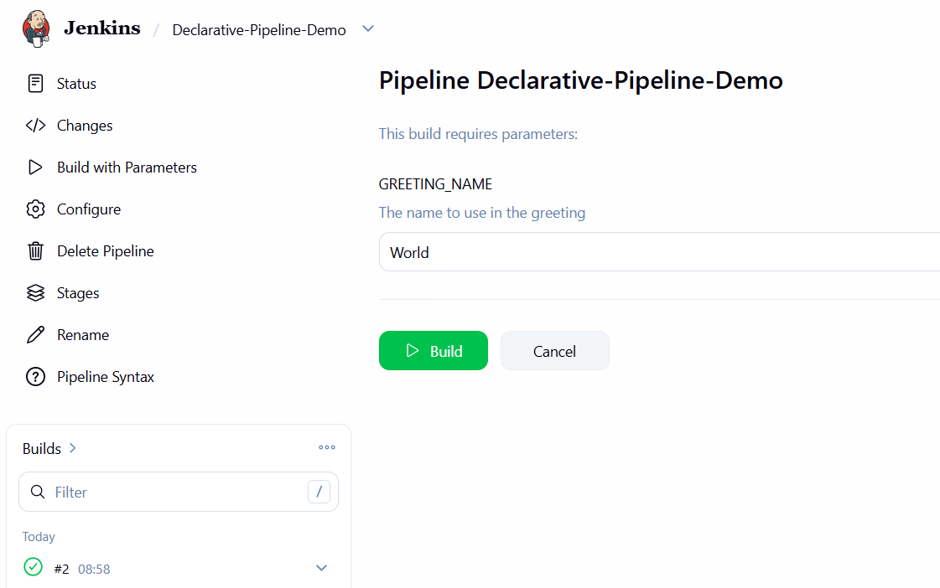

Build with custom parameter — Clicked "Build with Parameters," entered world for GREETING_NAME, and triggered the build.

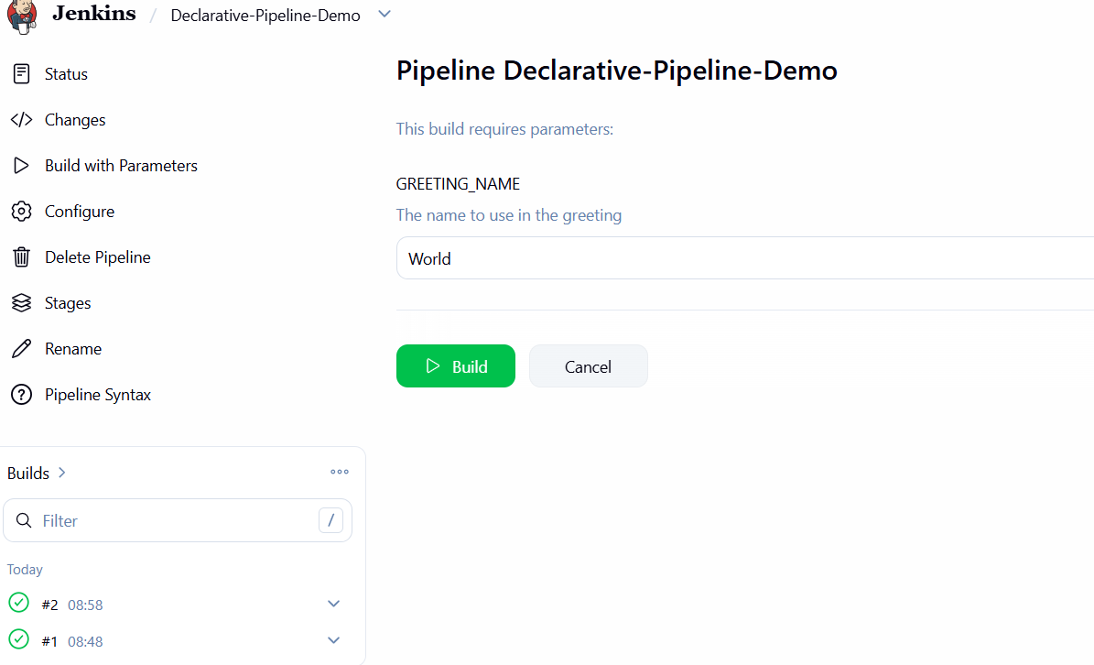
Verify in console output — Console Output showed Hello Vedika, confirming the parameter value was correctly picked up at runtime, with the rest of the pipeline (checkout, shell steps) completing

successfully.
